**Amazon Elastic Container Service Demo**

What are we trying to Achieve?

* Build a spring boot app into a container
* ECS containers run are running on port 80 (they will be hosted on Fargate Instances)

Step 1.

* Create a Spring boot app which you want to deploy
* The code used in this demo can be found in the following Github

<https://github.com/sfjbssept/Nishant/tree/main/spring-aws-deploy>

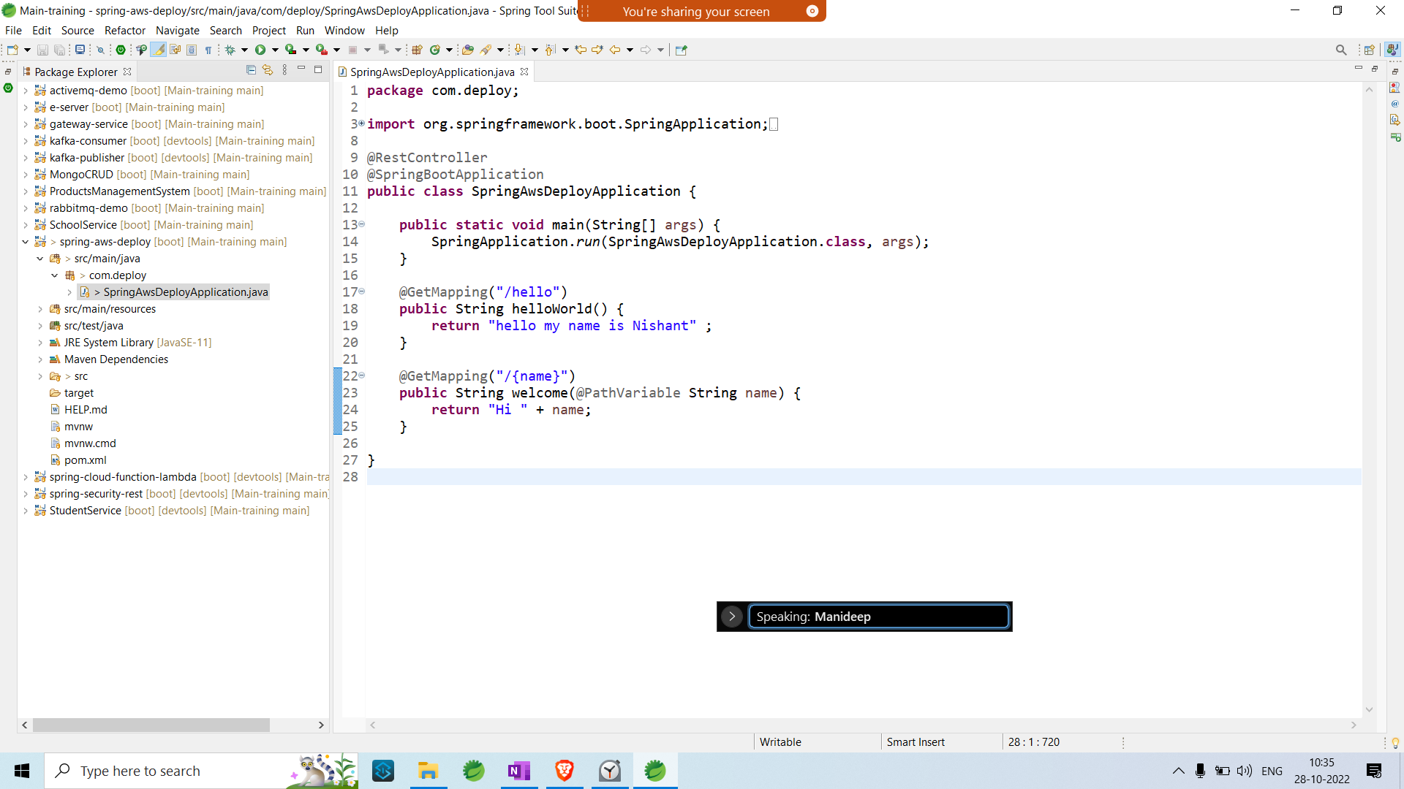

* Build the following into a docker Image (Make sure docker engine is running)
* Run **mvn spring-boot:build-image -Dmaven.test.skip=true** to build a docker image 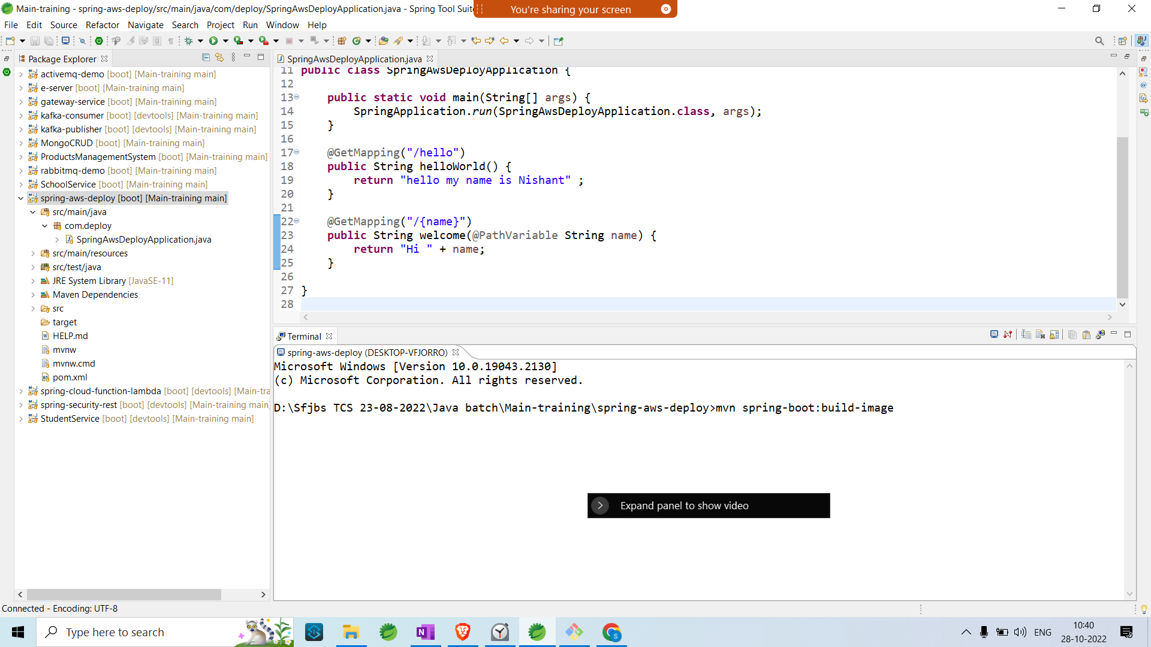
* After the build is successful Check the Image is present in Docker Desktop and If you are using Docker Toolbox run **Docker Image ls.**
* To start Docker Image in the same Terminal run **docker run --tty --publish 8081:8081 spring-aws-deploy:0.0.1-SNAPSHOT**
* Give a tag name to the Application by running **docker tag spring-aws-deploy:0.0.1-SNAPSHOT *docker username*/spring-aws-deploy:0.0.1-SNAPSHOT**
* Push the image to Docker hub by running **docker push *your docker username*/spring-aws-deploy:0.0.1-SNAPSHOT**
* After the push is complete, verify by going to your Docker hub account and checking the repositories.

Step 2.

* Go to AWS and Login
* Search for ECS and go to the service

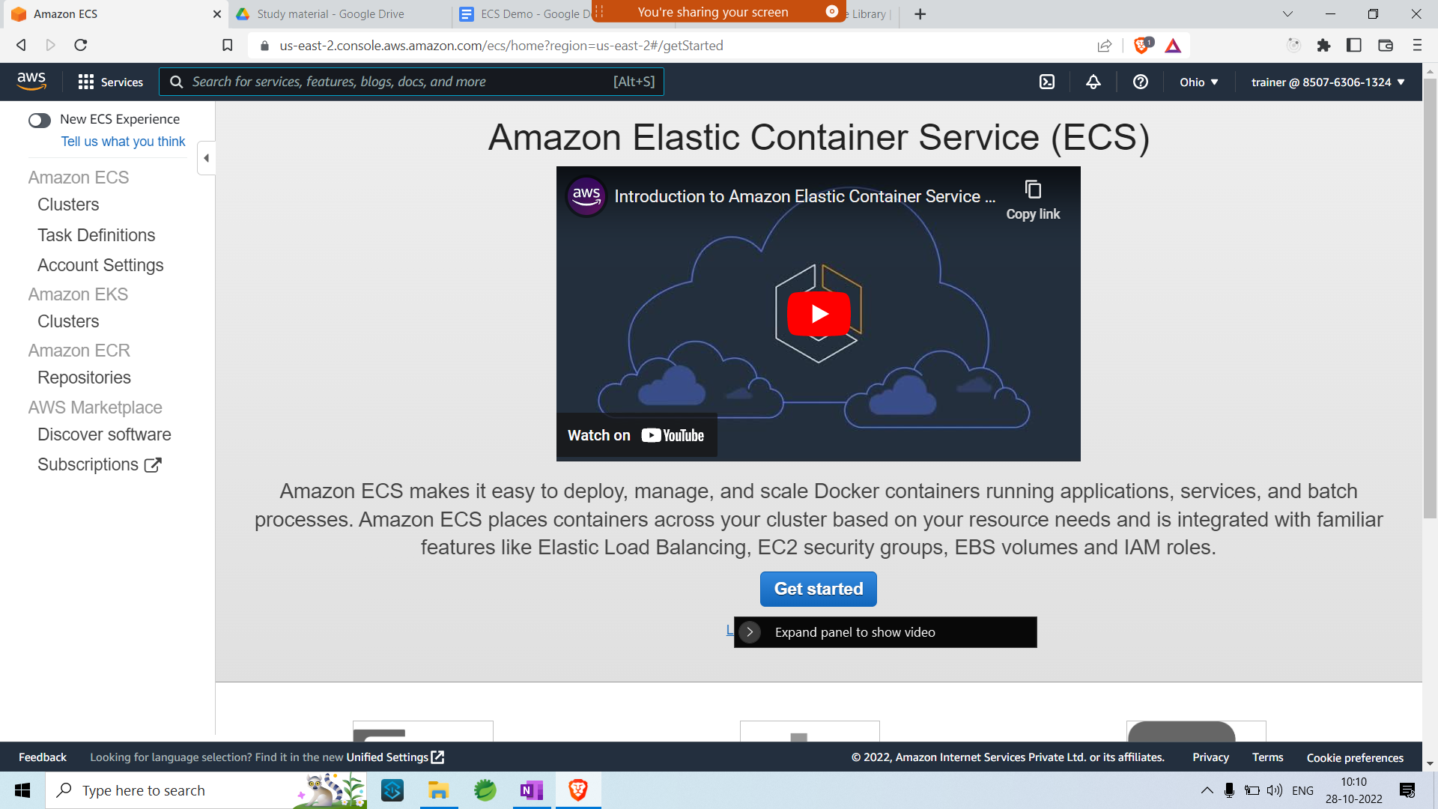

* Go to Task Definition and click on create Task Definition.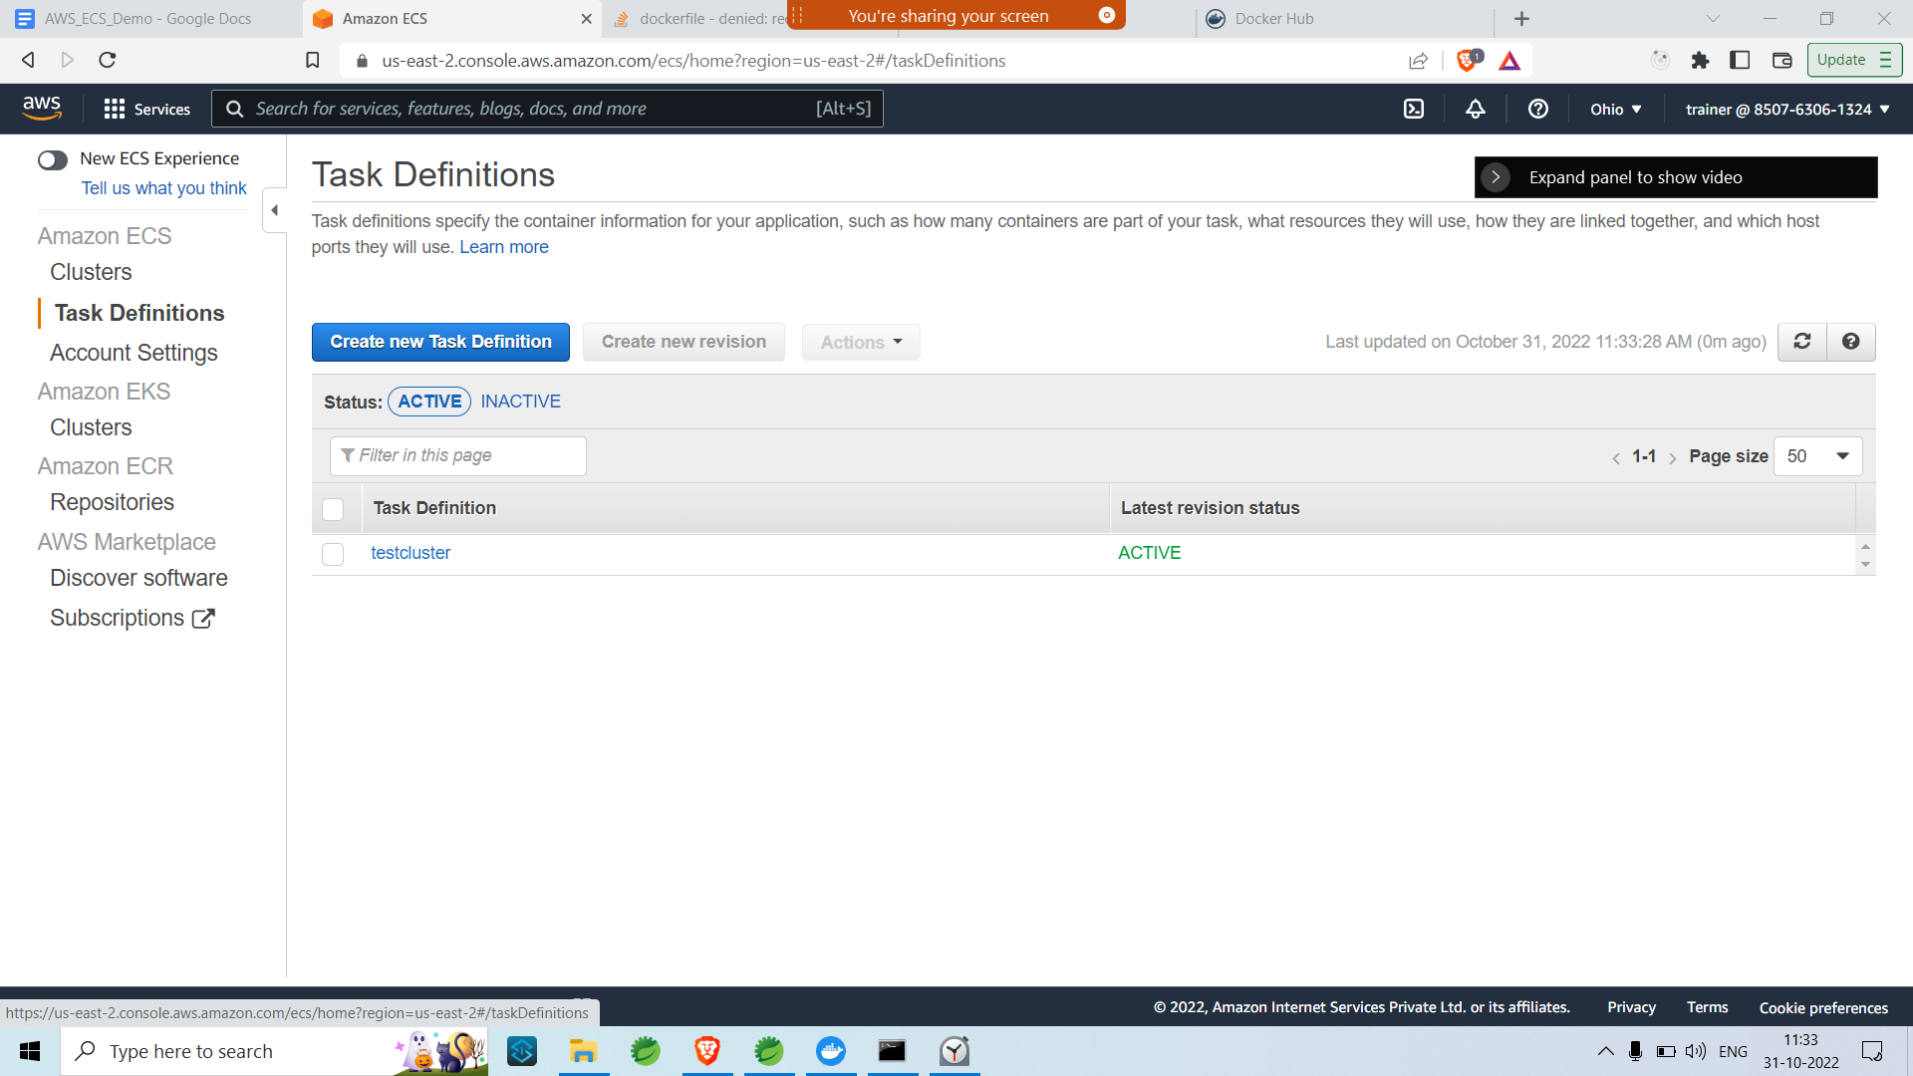
* Select Fargate as Select launch type compatibility
* 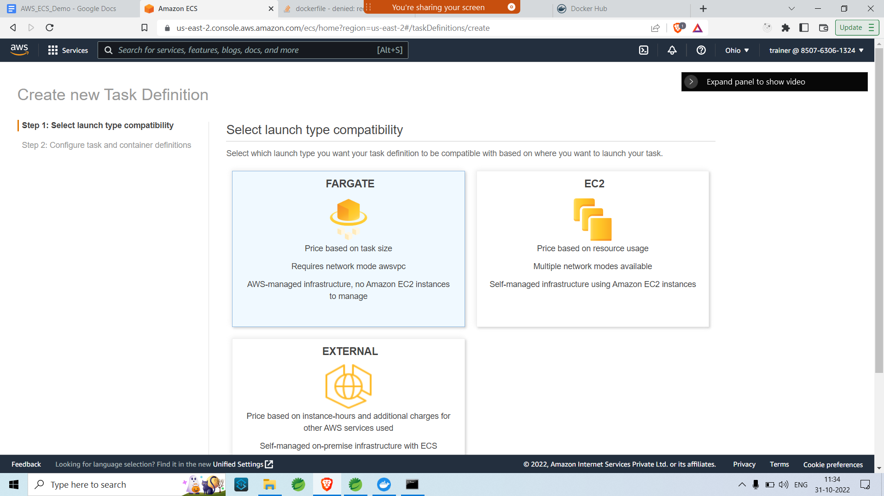
* Add the details as follows

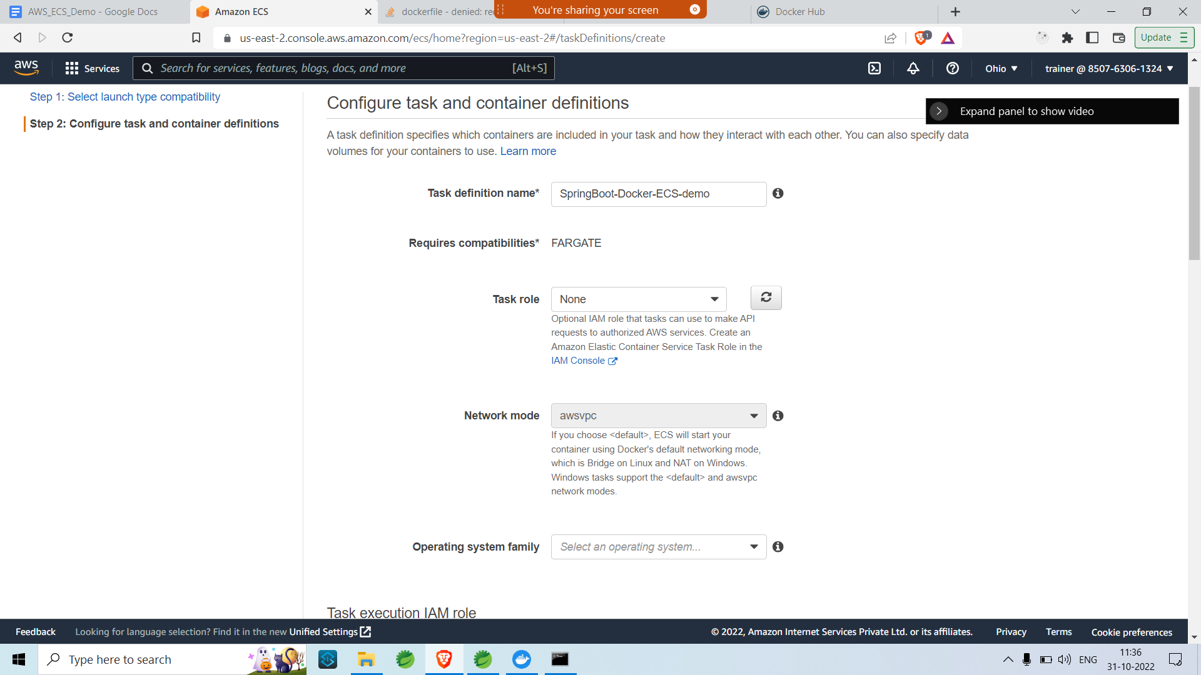

* Add Task memory as follows.

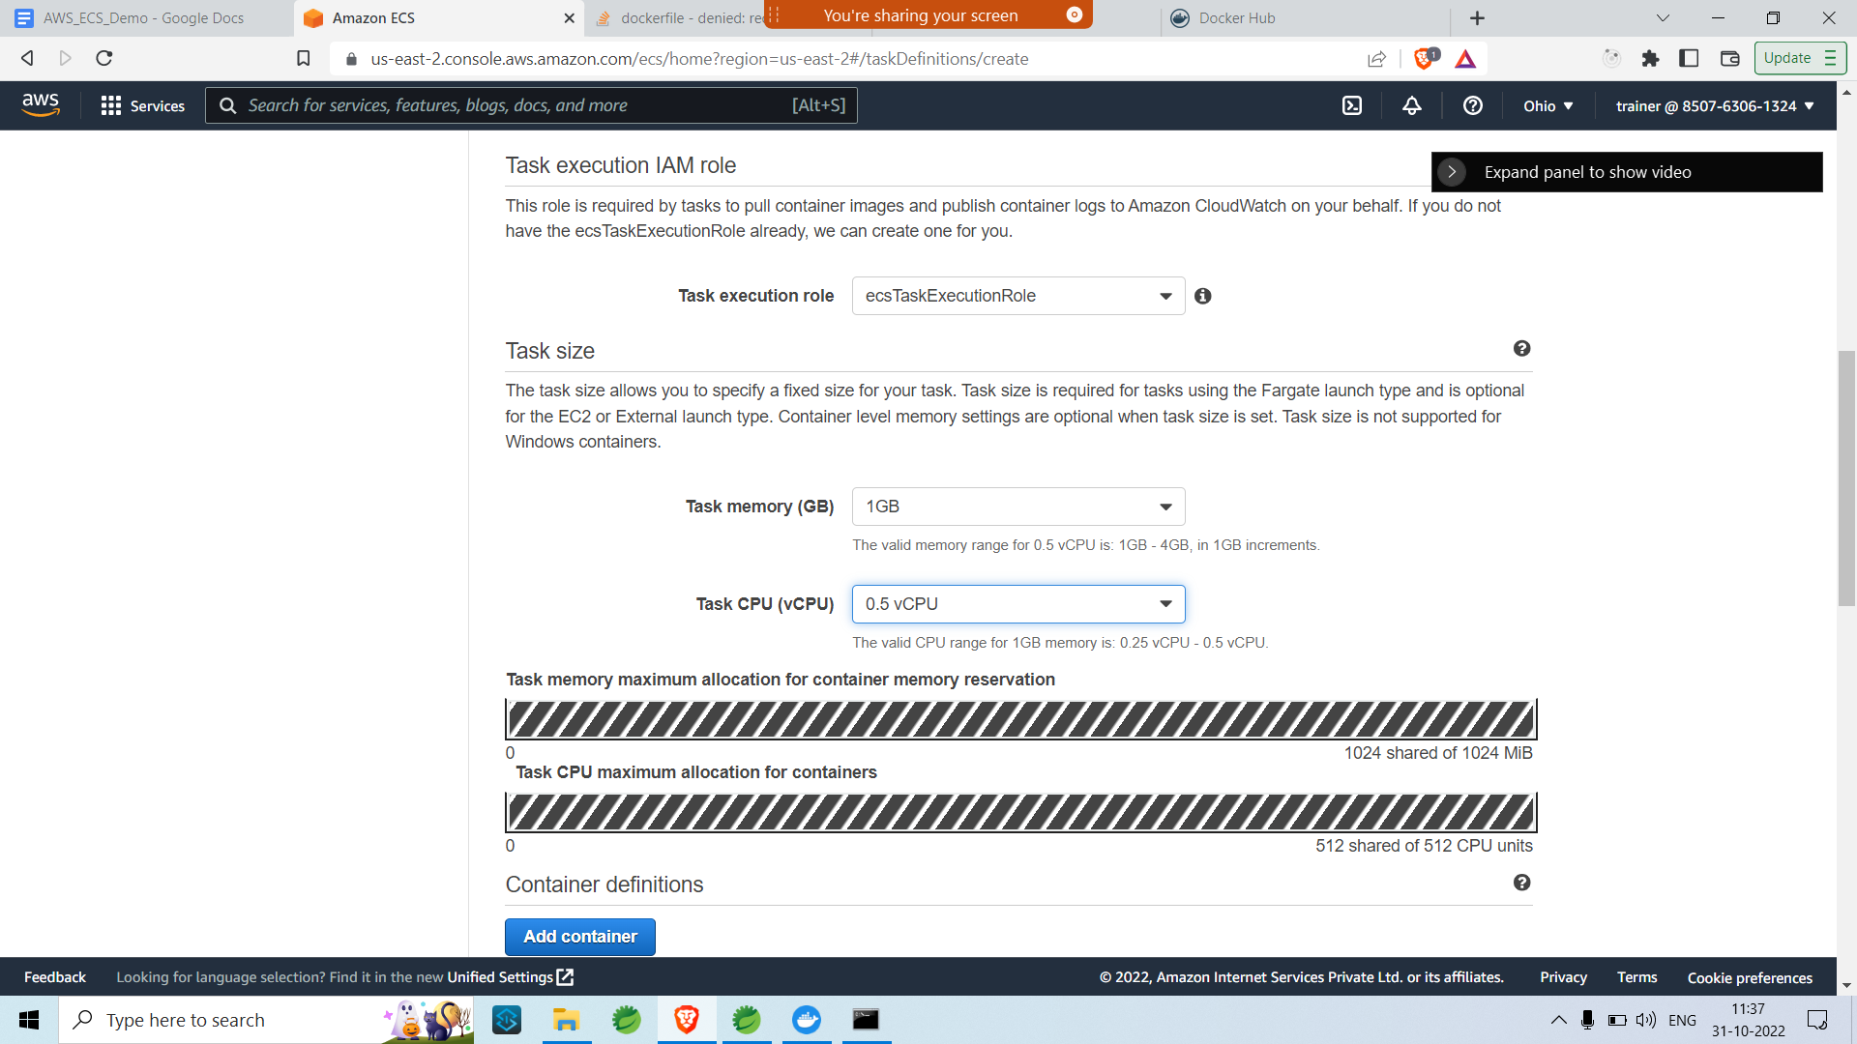

* Add the container

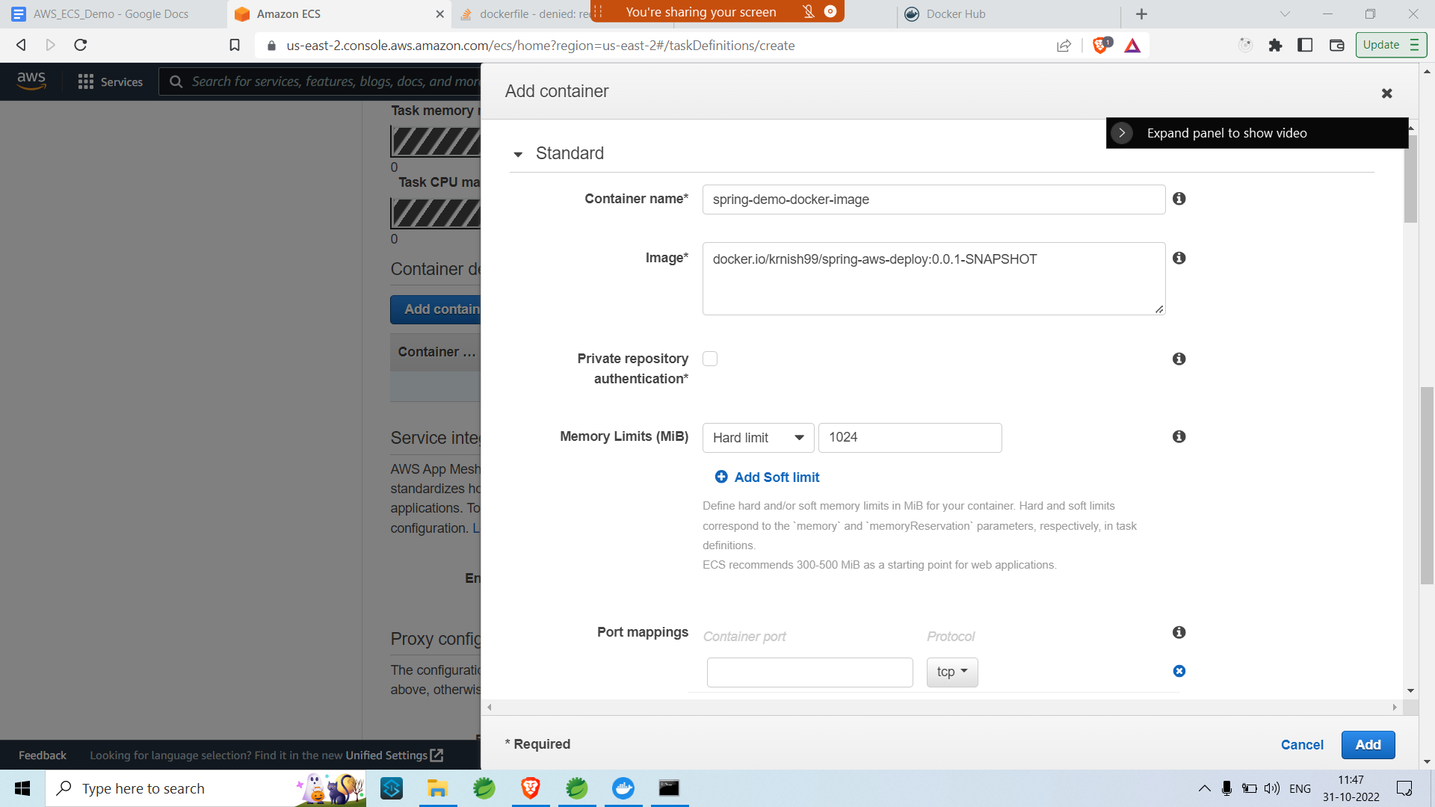

* Add port mapping

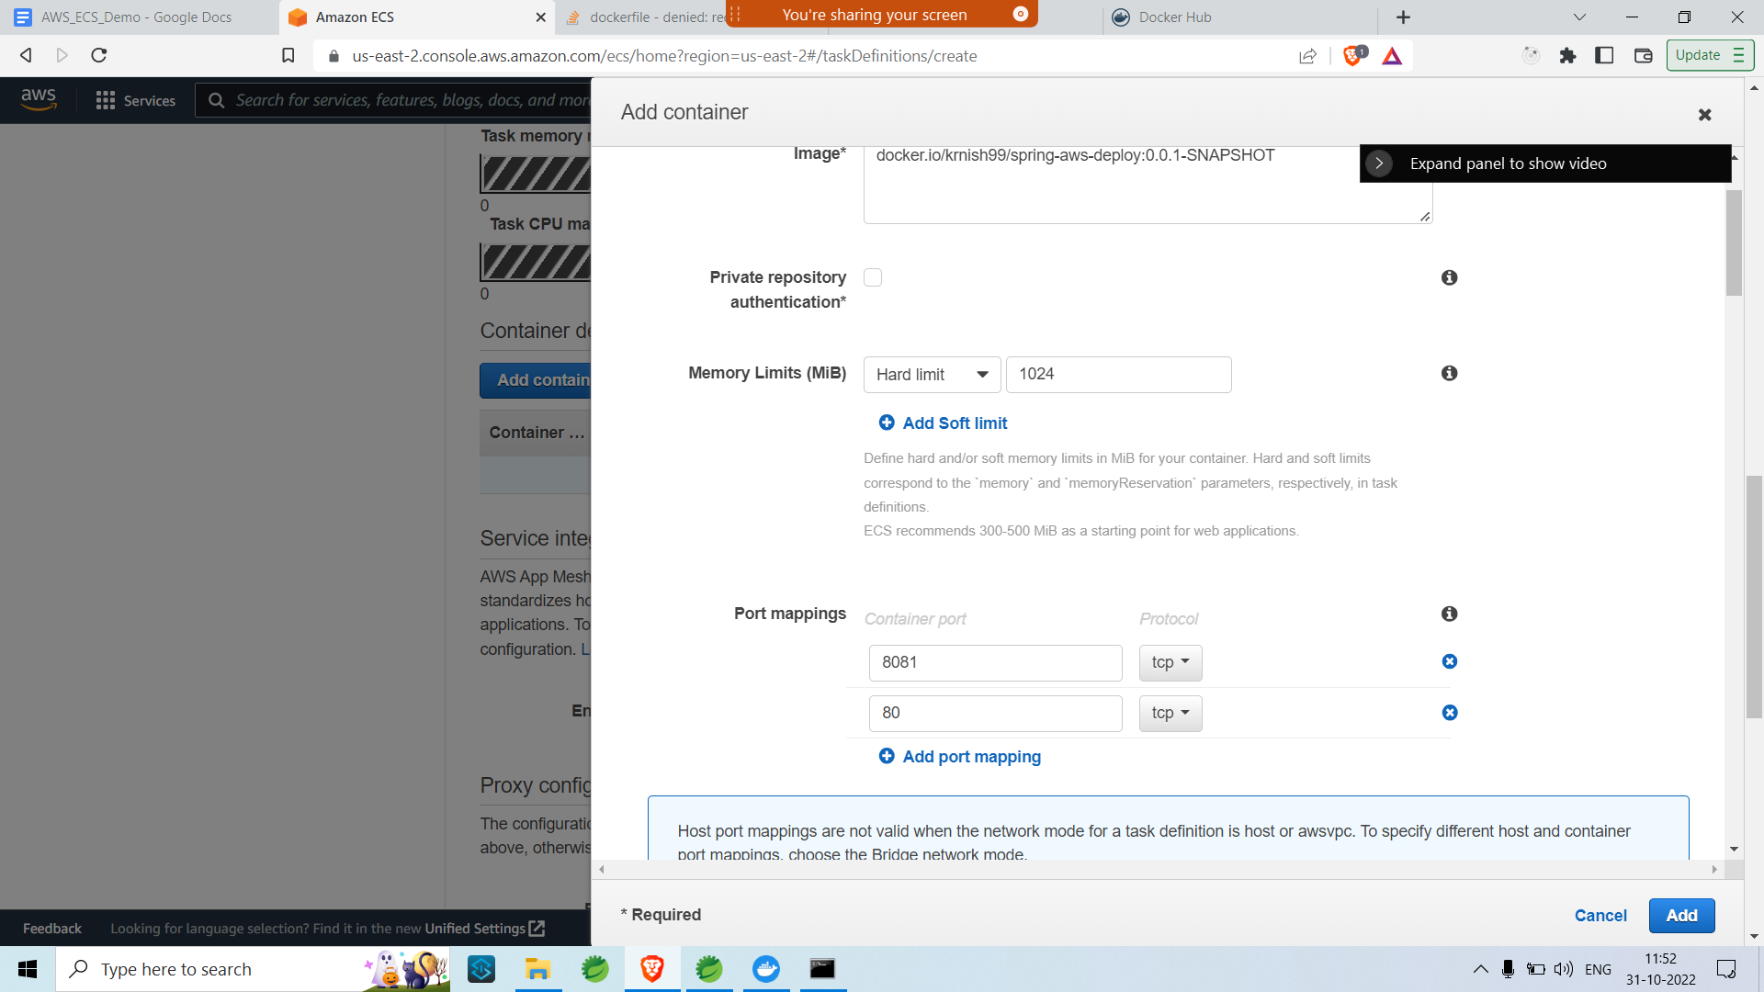

* Click on add and scroll all the way down and click on create

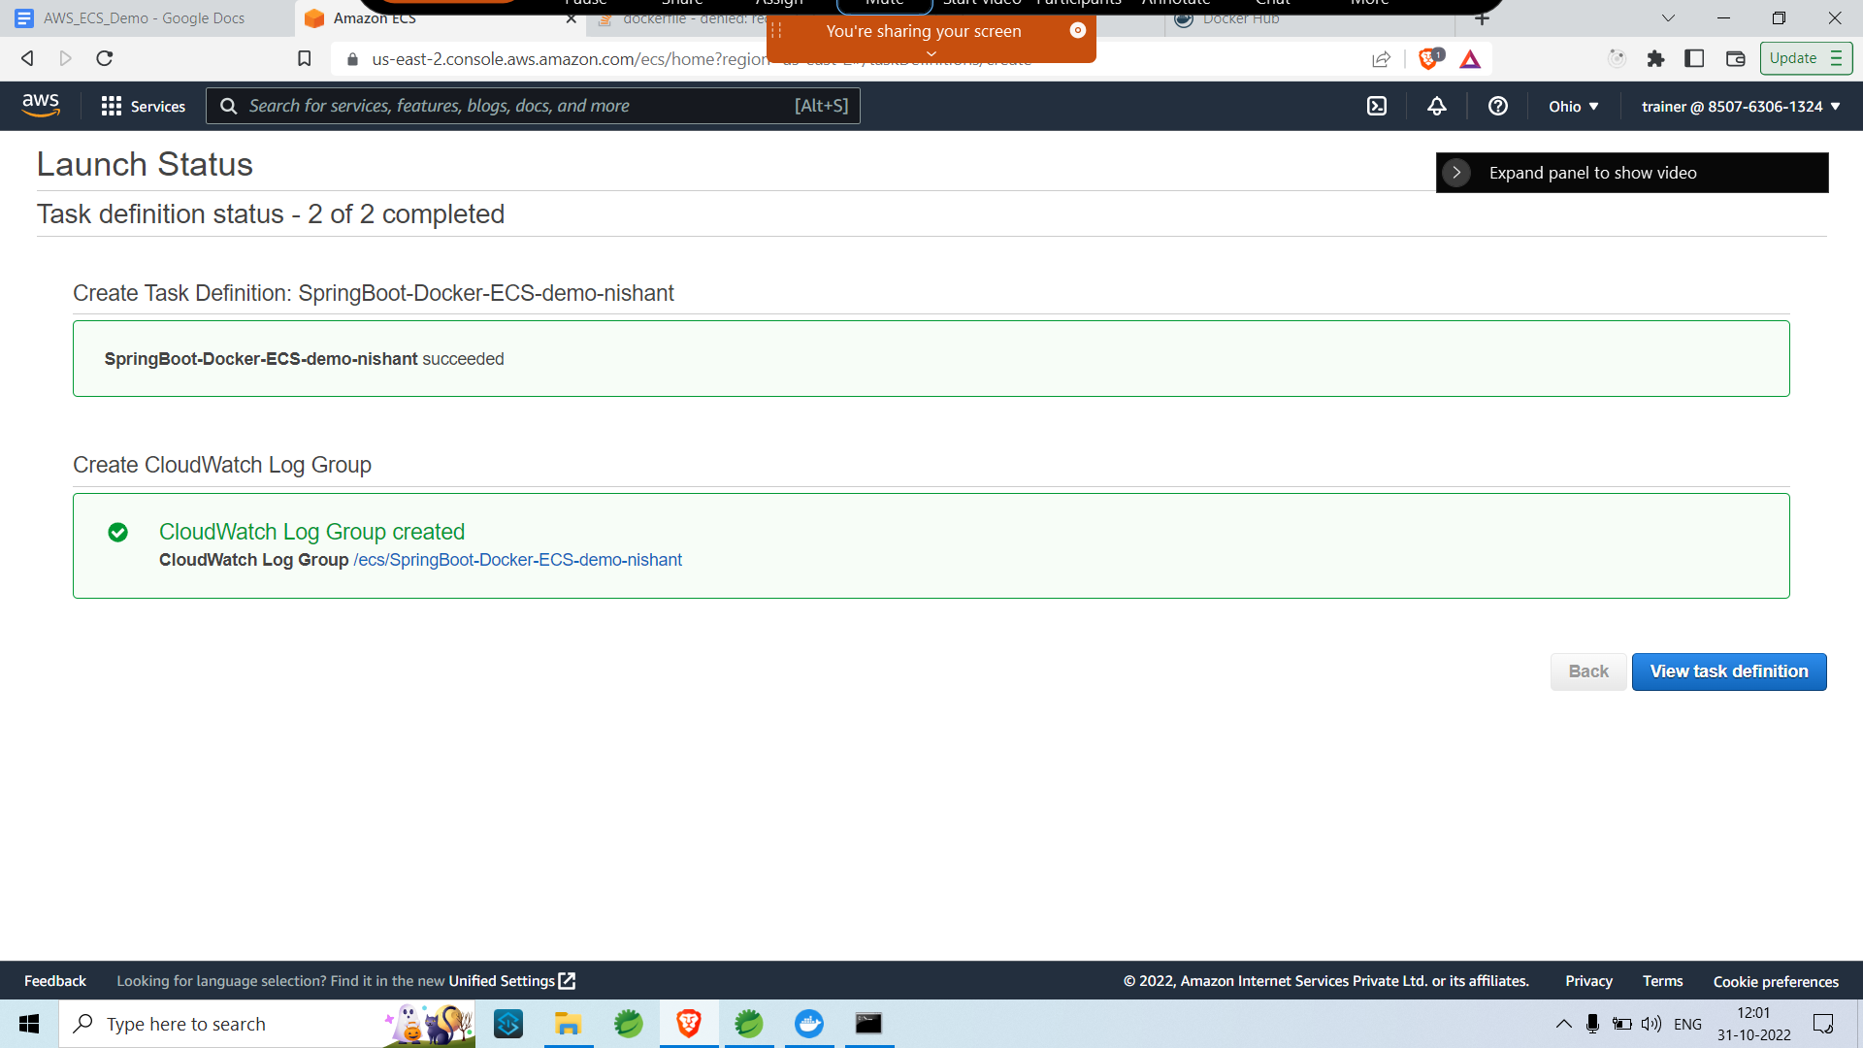

* Task definition should be created successfully.

Step 3.

* Go back to ECS home page and click on clusters so that we can create an AWS ECS Fargate cluster

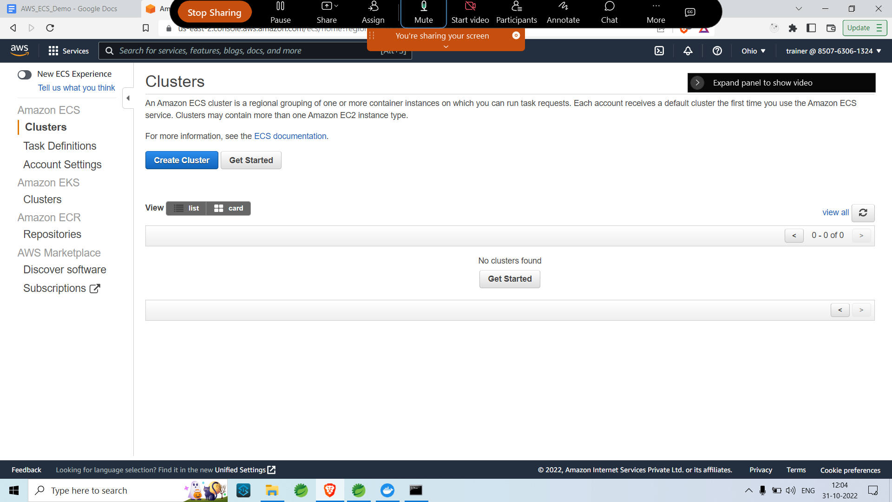

* Click on create cluster and Select Cluster Networking only.

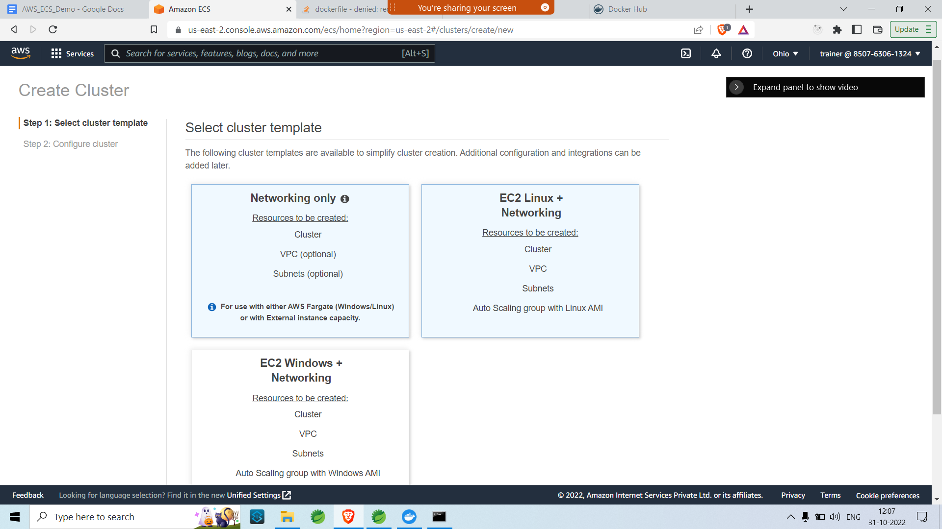

* Click on next and enter the Cluster Configurations

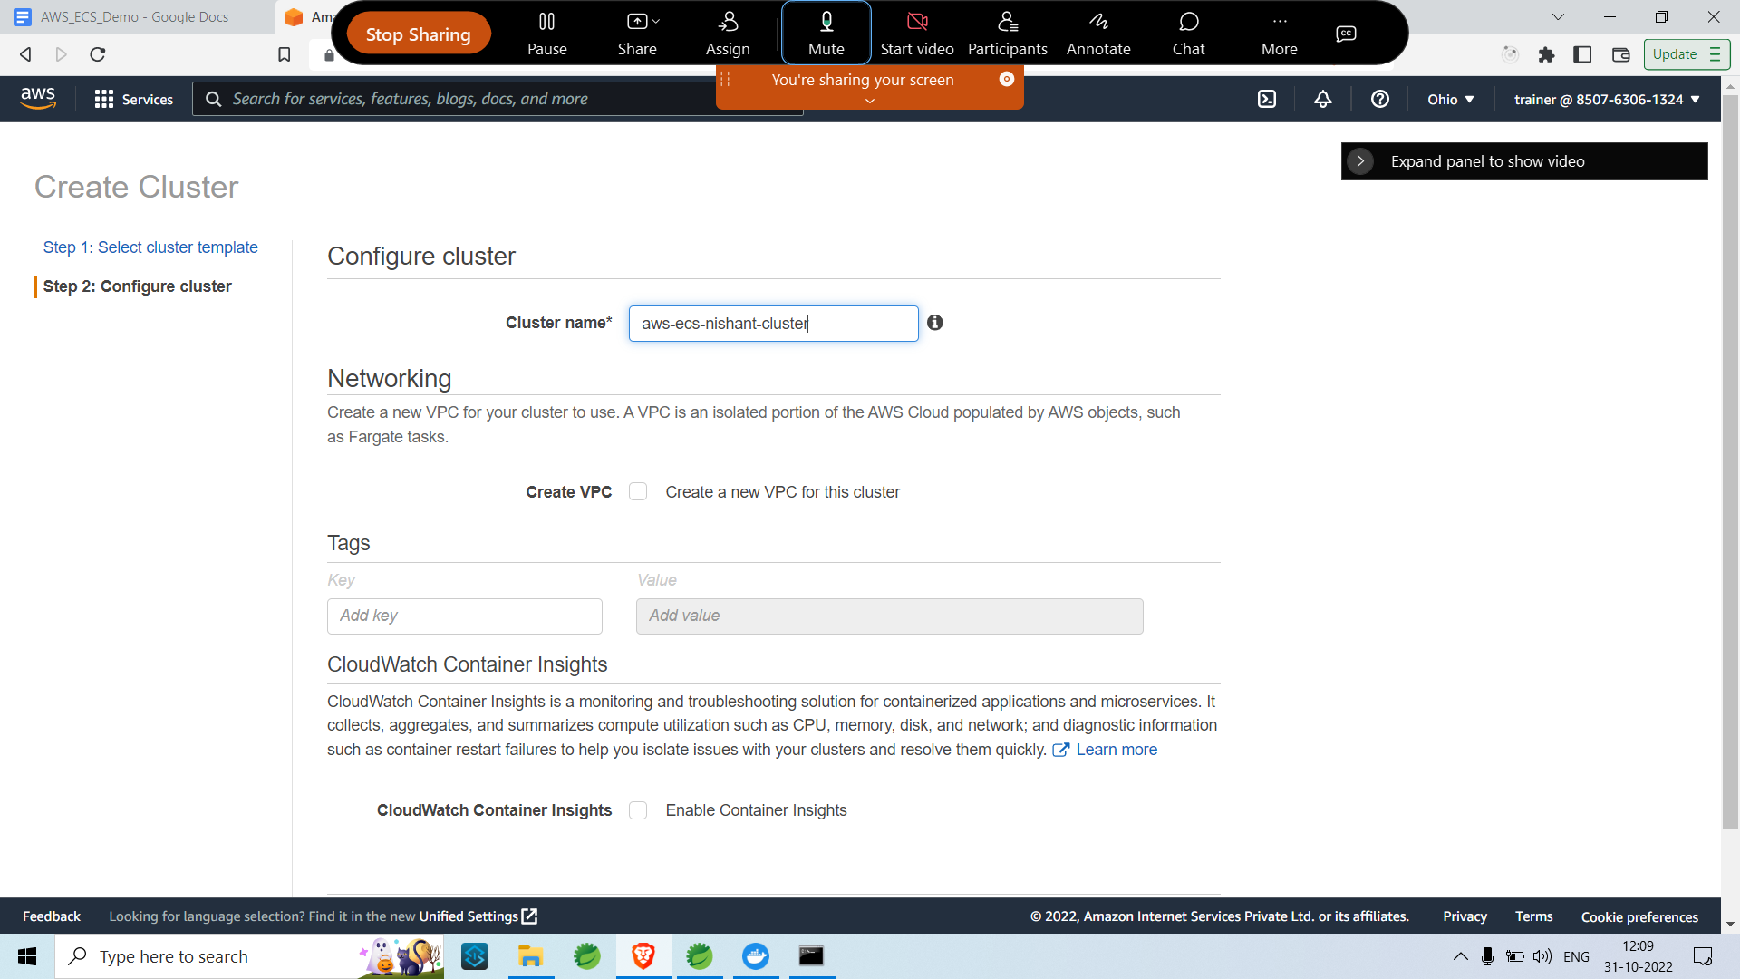

* Click on create , The cluster should be successfully created.

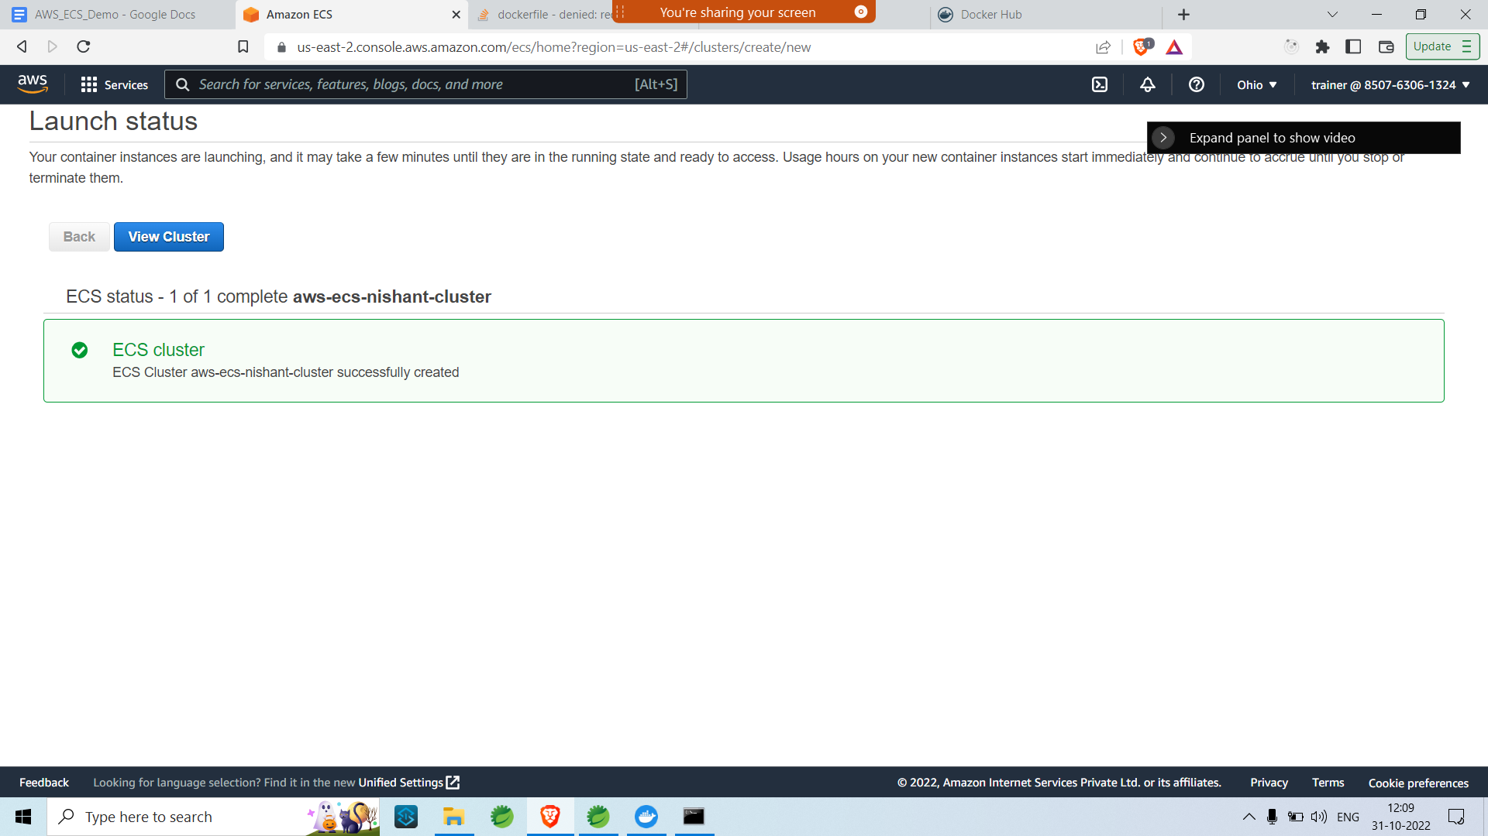

* Click on view Cluster
* Go to tasks and click on Run new task.

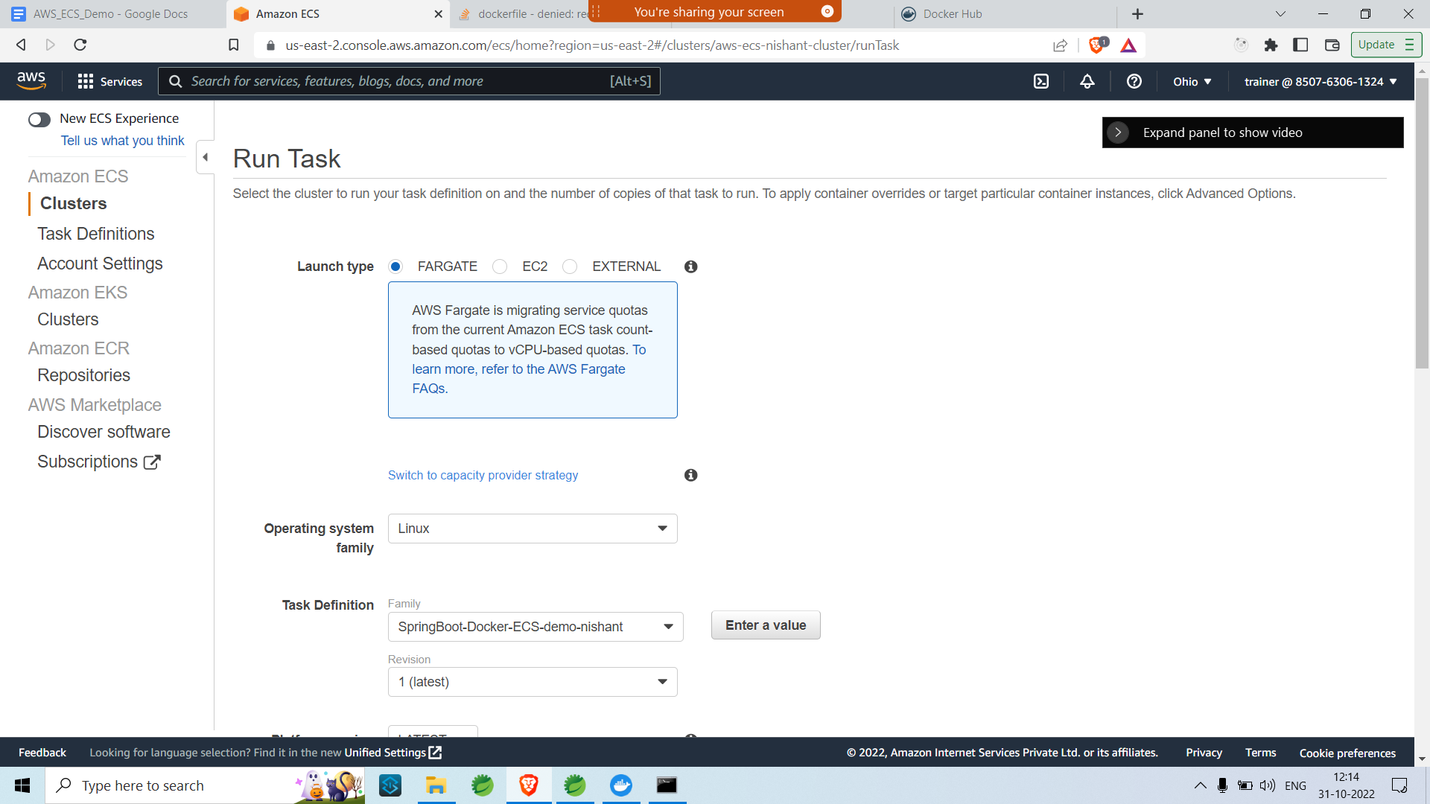

* Select the fargate as launch type and select the task definition as well as the OS.
* Configure VPC and Subnets

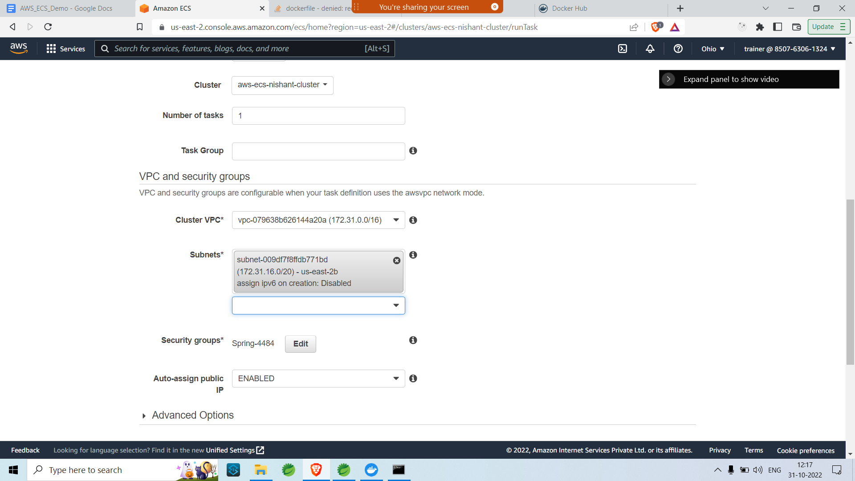

* Configure Security Groups

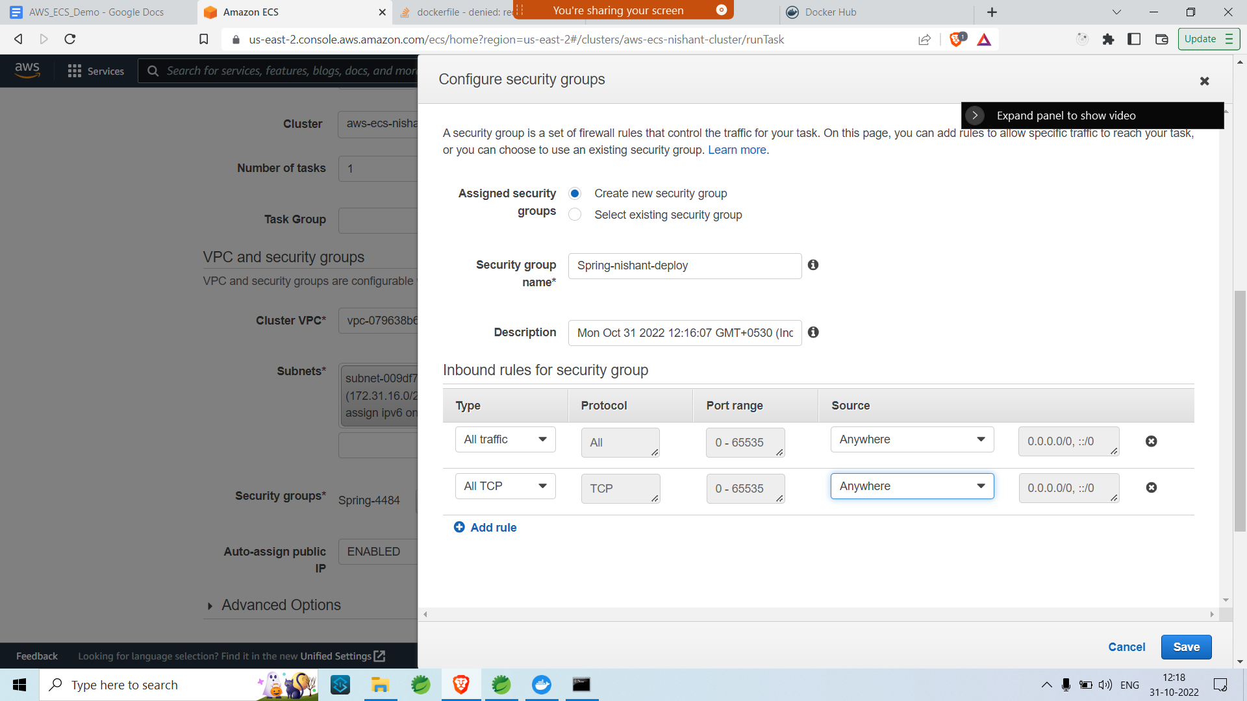

* Click on save and then click on Run Task.
* After the Task is RUNNING click on the Task.

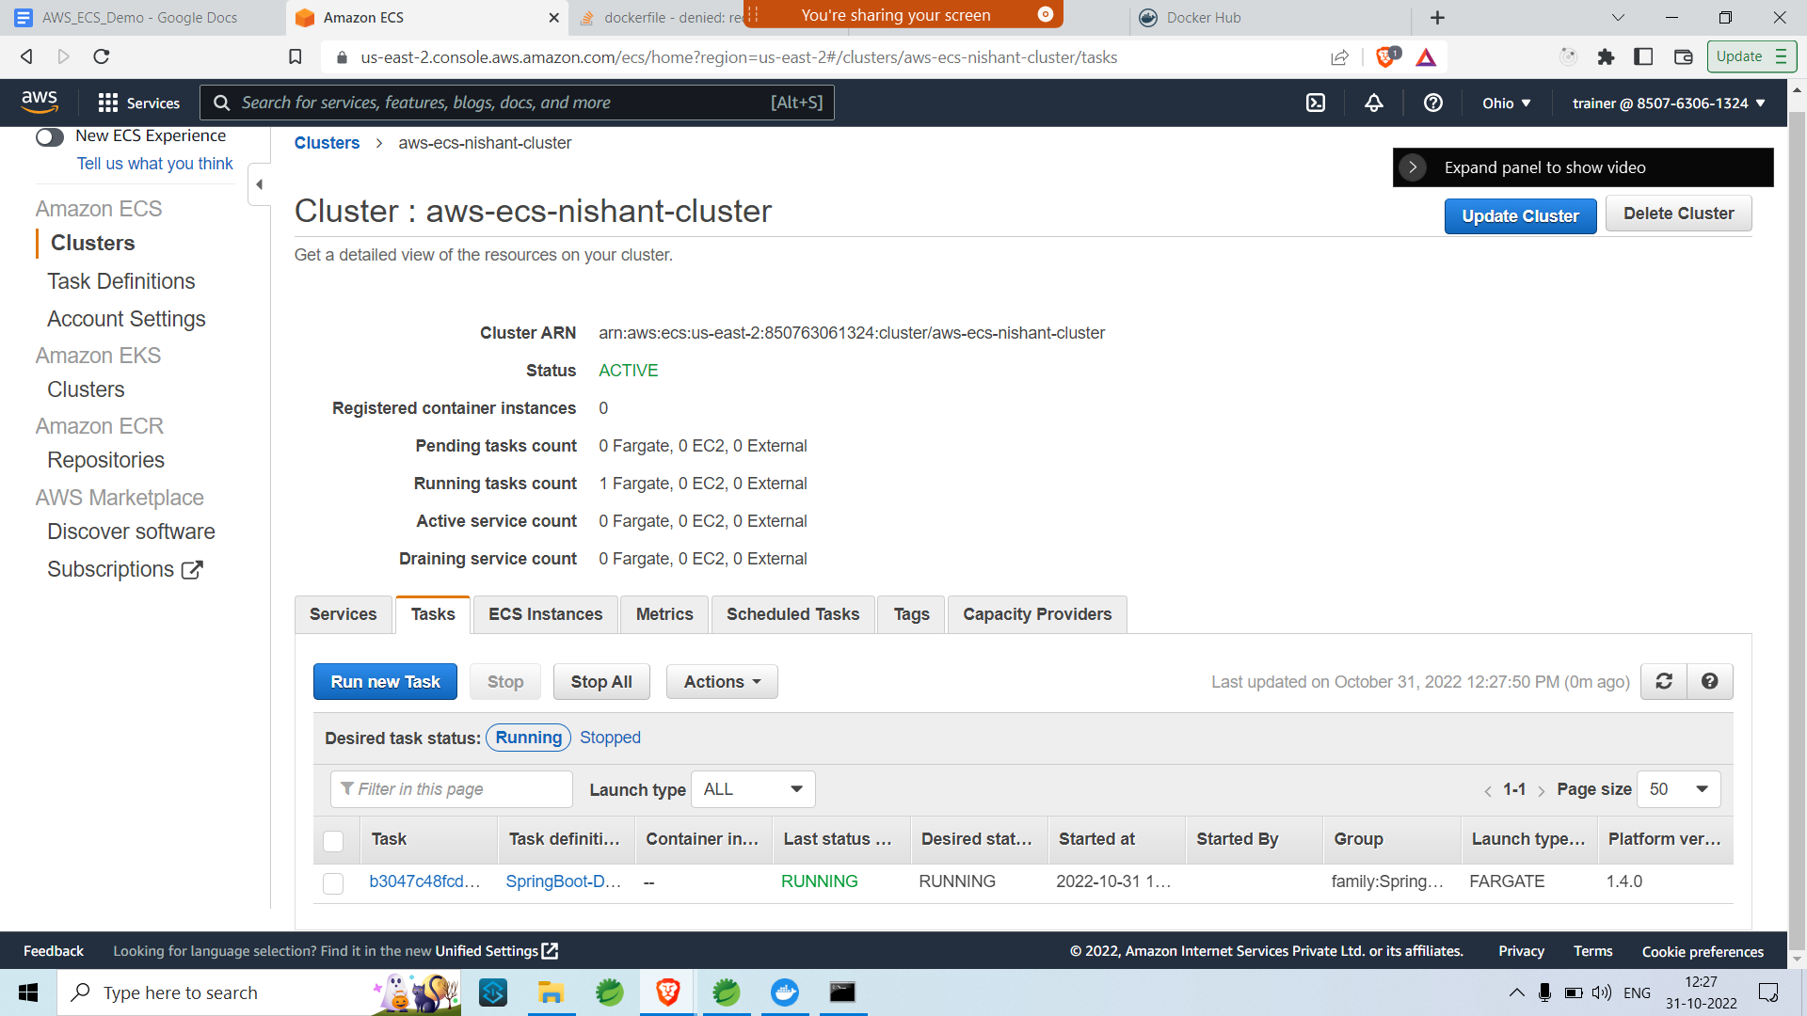

* Copy the public IP and go to a Private window
* Paste the IP:your port/path

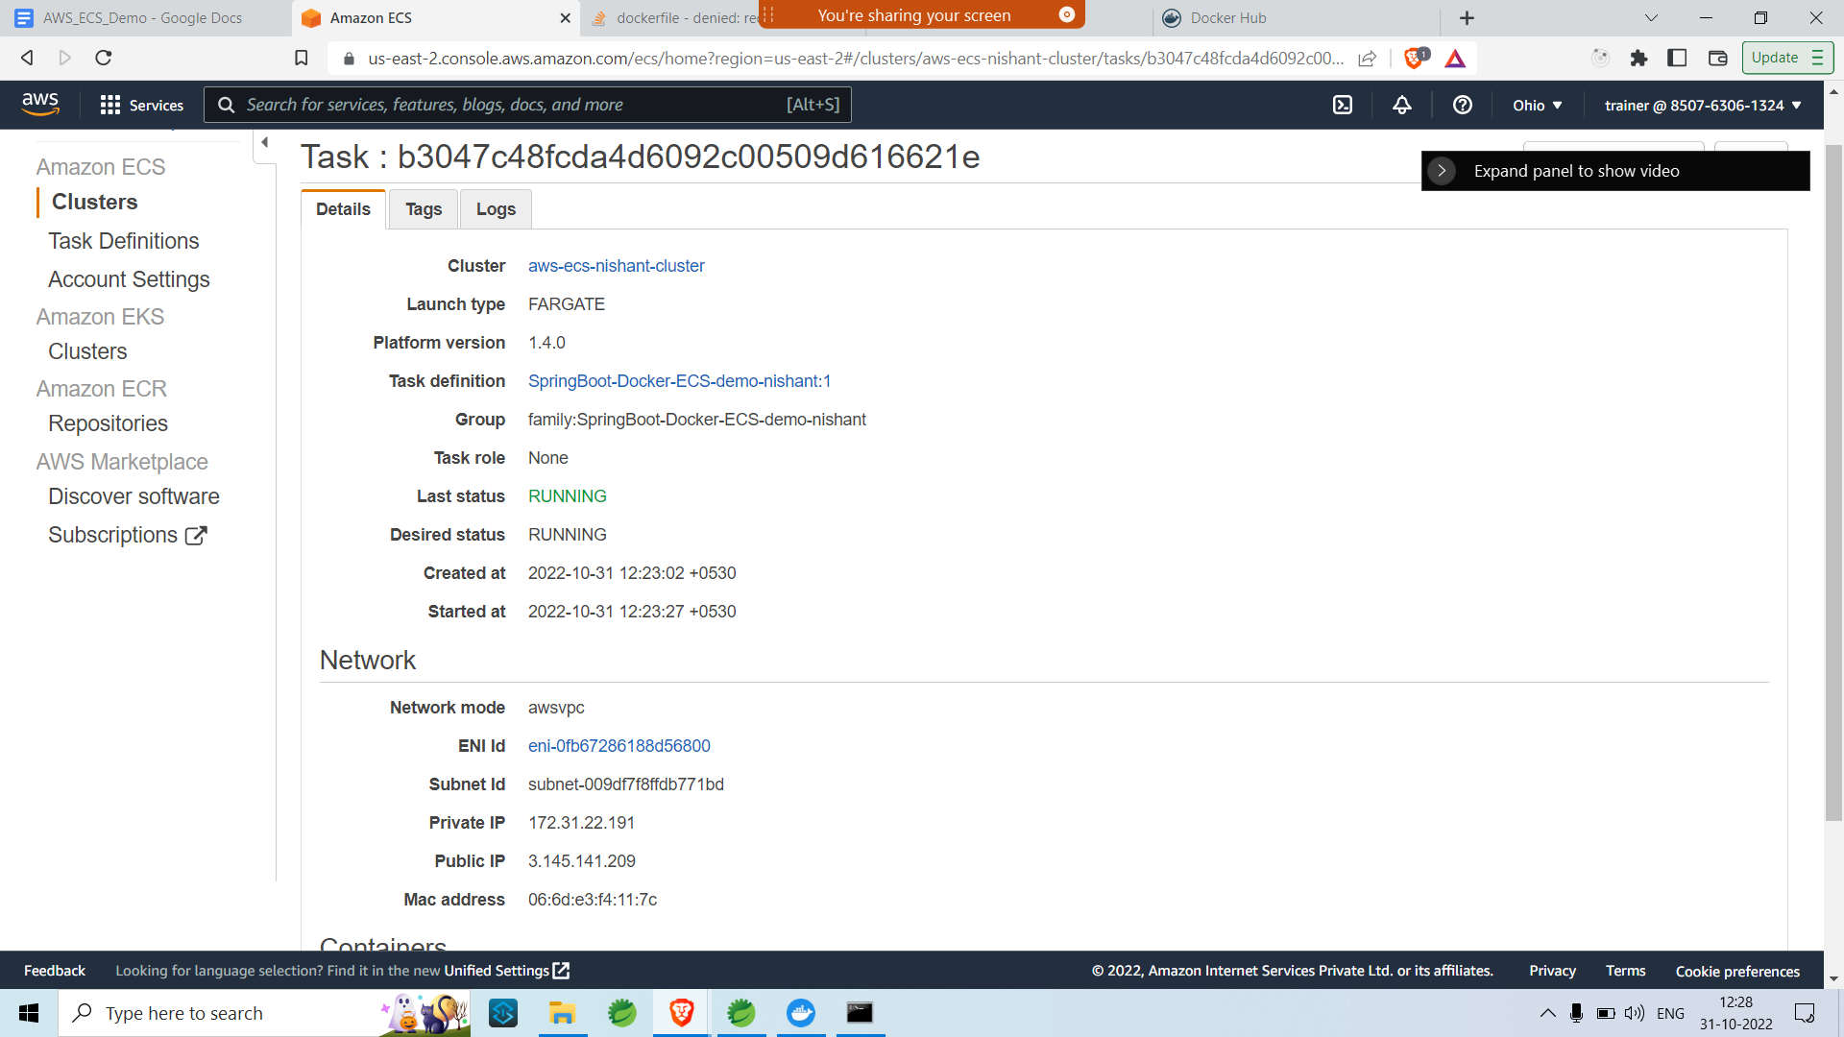

Go to browser and check your port

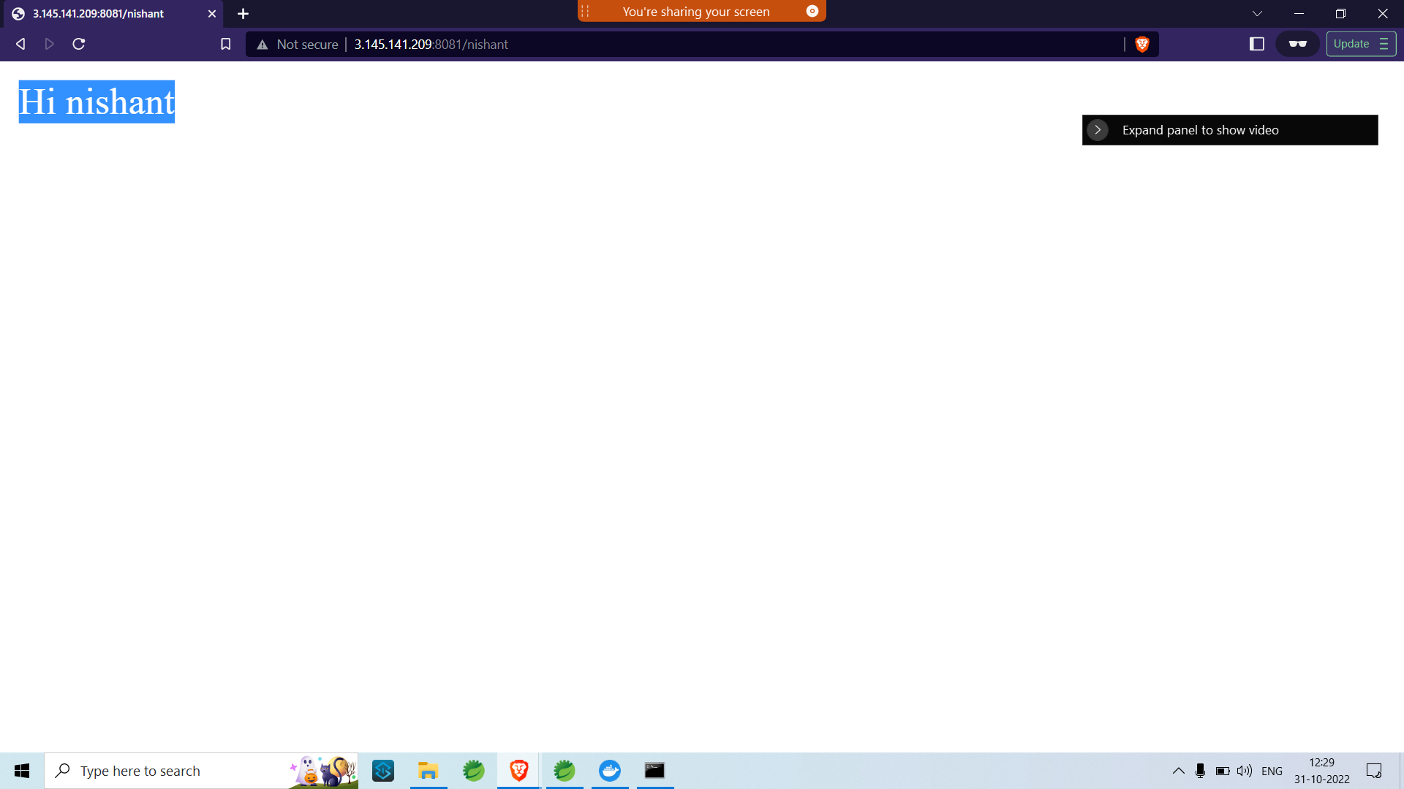

Thanks.